CSA1054:SOFTWARE ENGINEERING

LAB EXPERIMENT (DAY 3)

NAME:C.GNANENDRA

REG NO:192211158

EXPERIMENT 1: Draw and validate Flowchart to compute quotient and remainder between two integers can be calculated by using the division ( / ) and modulus ( % ) operators respectively. To compute the remainder of the division of two floating point numbers, the library function fmod() is used. This function considers quotient as an integer number and the remainder as a floating-point number.

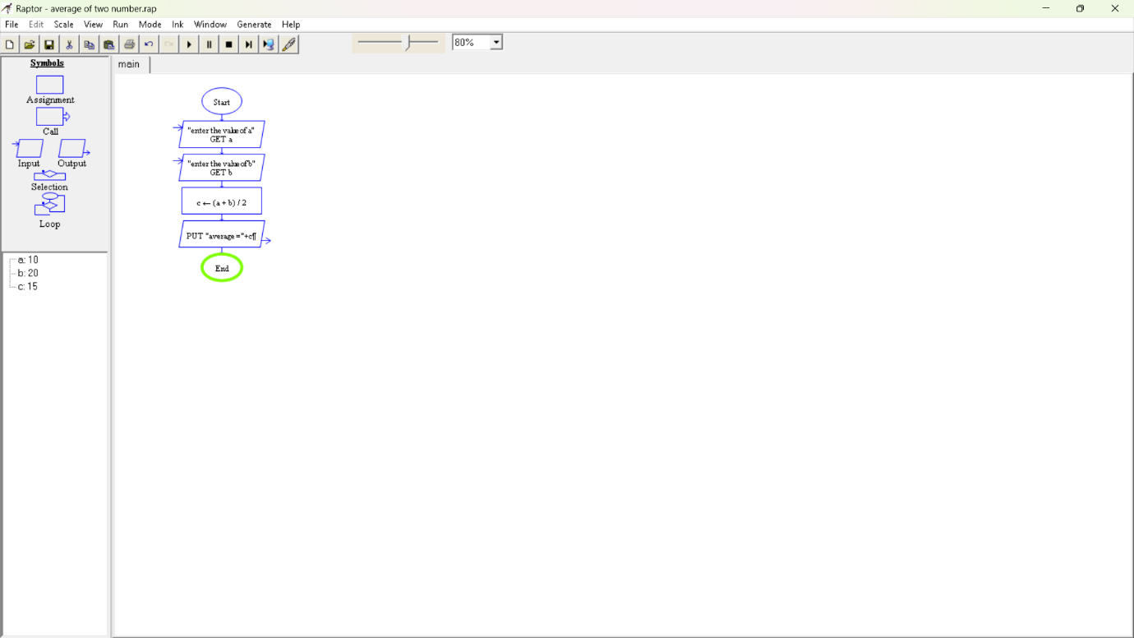

EXPERIMENT NO 2:Palindrome

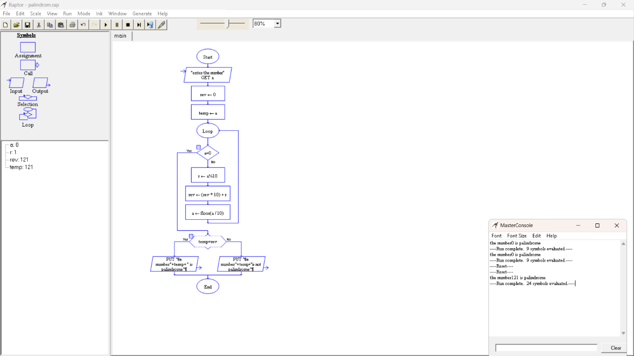

Max palindrome

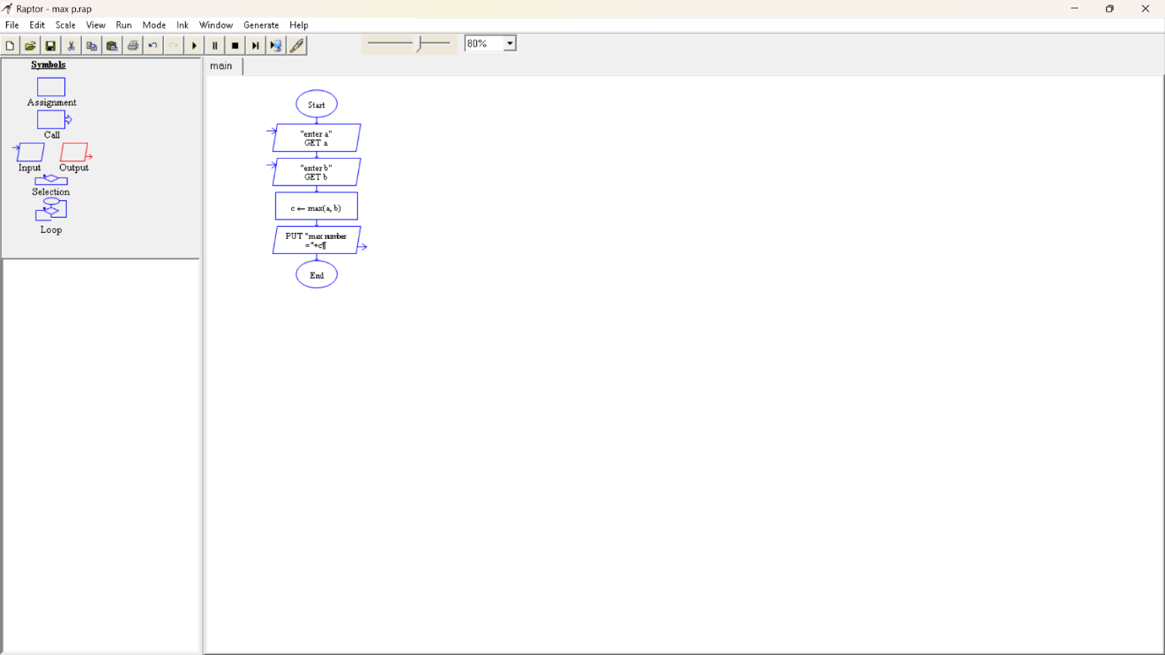

Min palindrome

